APPLICATION/RENEWAL FORM 2022-2023
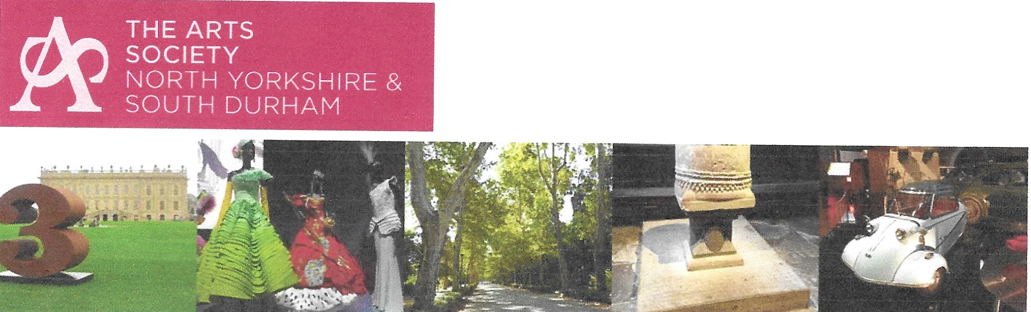

Name(s)______________________________________________________

Address______________________________________________________

_____________________________________________________________

___________________________________ Postcode: __________________

Tel: ____________________________ E-mail:________________________

Please indicate the type of membership and payment method: cheque ( ) bank transfer ( )

MEMBERSHIP FEE £55.00 per person ( )

I enclose a Membership Fee of £………. payable to the North Yorkshire & South Durham DFAS and my completed renewal form OR I have paid by bank transfer to: NY&SDDFAS, account number 00017726, sort code: 40-52-40. Be sure to give your surname and initials as reference when you do the bank transfer; send the completed renewal form to me (David Phillips) and mark payment as ‘bank transfer’, then I can complete the renewal.
Please return this form, with your cheque OR mark paid by bank transfer
To David Phillips, Membership Officer, 8-10 George Street, Barnard Castle, DL12 8JD
E mail: munslowboy@outlook.com

If you do not intend to renew please let me know so that I can keep our records up to date.

The Arts Society North Yorkshire & South Durham is always looking for volunteers to help with the running of the Society. Please tick here □ if you would be willing to help.

Preferred method of communication
So that we can let you know about Society news and events, please tick the relevant box to indicate how you would prefer to be contacted by us in future.
◻ Email (preferred) ◻ Telephone ◻ Post
◻ Please tick here if you have accessibility issues.

GDPR Compliance: please tick relevant boxes
◻ Members’ details will be processed fairly and lawfully in order to satisfy the agreement entered with you on your admittance to membership. This will ensure that you receive the latest news and information about all upcoming events.
◻ Members’ details will be passed to “The Arts Society” to enable inclusion on the mailing list of the quarterly magazine and other communications including information about any upcoming national events or items of legitimate interest .
◻ Members’ details may be passed to “The Arts Society Area”, or other affiliated societies, for the purposes of disseminating relevant information of legitimate interest.
◻ Your details will be kept safely and securely and you have the ability to opt out of our communications at any time.
Please indicate your acceptance of the above by signing below

Signed …………………………………………………………. Date ……………………………..

Gift Aid Declaration: Please place an X in the box below if you want to Gift Aid your past, present and future donations to The Arts Society/National Association of Decorative and Fine Arts Societies (NADFAS). This will allow us to claim an additional 25% from HMRC. ◻
If you don’t intend to renew please let me know so that I can keep our records up to date.

